**File Creation Task**

**Task Description:**

1. Create a directory called ""my_folder"", navigate into it, and create a file named ""my_file.txt"" with some text. Then, create another file named ""another_file.txt"" with some text. Concatenate the content of ""another_file.txt"" to ""my_file.txt"" and display the updated content. Finally, list all files and directories in the current directory.
2. Create 20 files with .txt extensions and rename the first 5 files to .yml extension and Print the latest created top 5 files among the total no of files".

**Solution : 1**

✅ 1. Create a directory and move into it

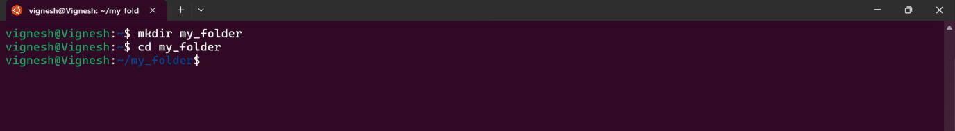

🡪 mkdir: creates a folder.

🡪 cd: moves you into that folder.

✅ 2. Create my_file.txt and another_file.txt with some text

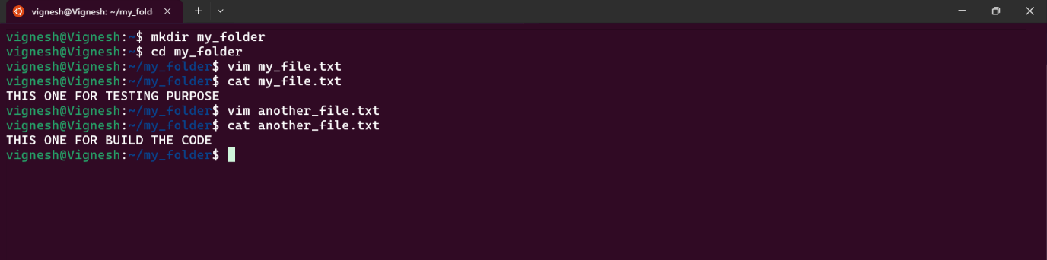

🡪 I used vim editor for creating file and adding text.

✅ 3. Concatenate content of another_file.txt to my_file.txt & Display updated content of my_file.txt

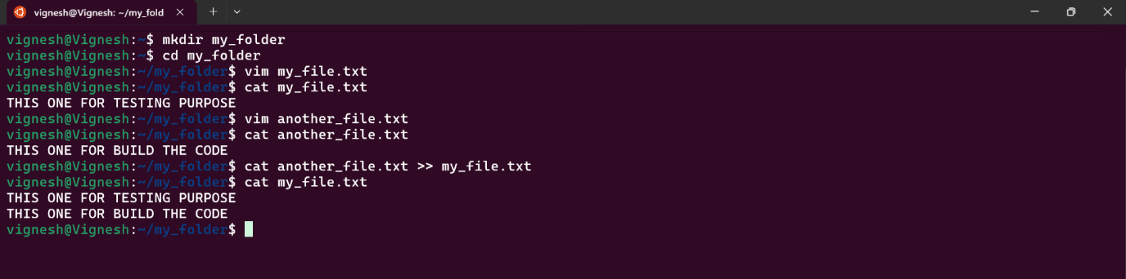

🡪cat reads the content.

🡪 >> appends the content to the file.

✅ 4. List all files and directories in the current directory.



🡪ls – lists directory contents.

🡪a – shows hidden files.

🡪-l – uses a long listing format (shows permissions, ownership, size, etc.).

**Solution : 2**

✅ 1. Create 20 .txt files

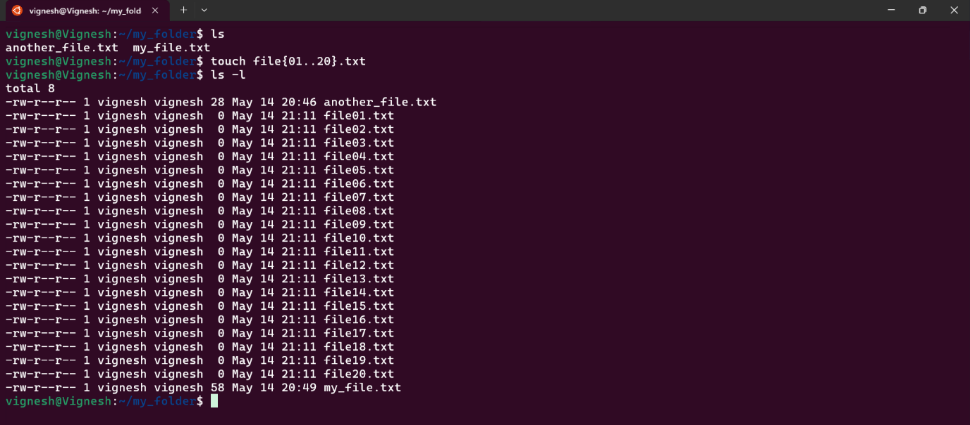

🡪touch file{01..20}.txt = This creates files from file01.txt, file02.txt, ..., file20.txt.

✅ 2. Rename first 5 .txt files to .yml

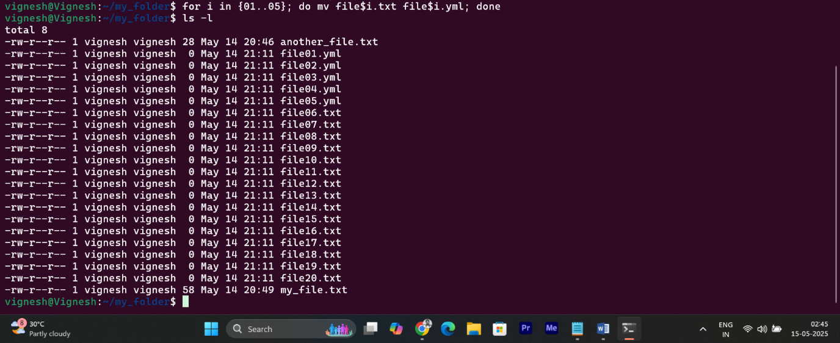

🡪 for i in {01..05}; do mv file$i.txt file$i.yml; done (used this loop format)

🡪 mv renames the file.

✅ 8. Print the latest 5 created files among all the total no. of files

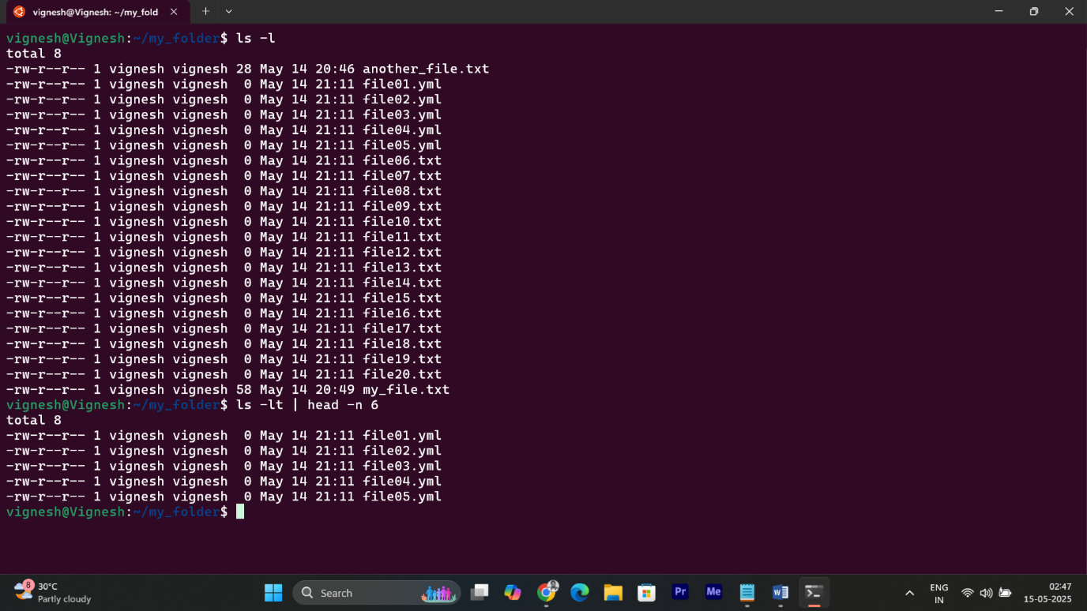

🡪ls -lt: lists files by modified time, newest first.

🡪head -n 6: shows top 5 files.